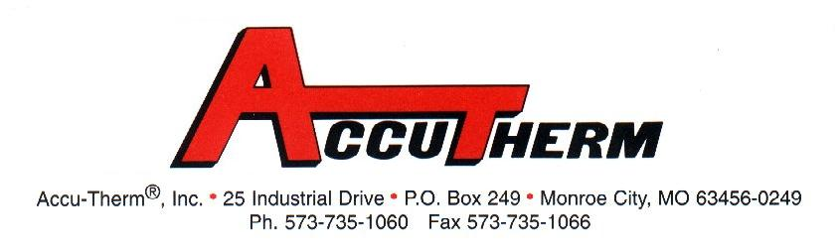
CIRCULATION HEATERS
Date: |  | Quote Number: |  |  |  |  |  |  |  |  |  | AT Part # |  |  |  |  |  |  |  |  |  | Quoted by:
Company: |  |  |  |  |  |  |  |  | Contact: |  |  |  |  |  |  |  |  |  |  |  |  |  |  | User
Street: |  |  |  |  |  |  |  |  | Phone: |  |  |  |  |  |  |  |  |  |  |  |  |  |  | Distr.
City: |  |  |  |  |  |  |  |  | Fax: |  |  |  |  |  |  |  |  |  |  |  |  |  |  | OEM
State: |  | Zip: |  |  |  |  |  |  | Email: |  |  |  |  |  |  |  |  |  |  |  |  |  |  | Com.
MATERIAL  TO BE HEATED |  |  |  |  | Type of Oil: |  |  |  |  |  |  |  |  |  |  |  | Type of Gas:
 |  |  |  |  | Heat Transfer Oil: |  |  |  |  |  |  |  |  |  |  |  | Other:
 |  |  |  |  | Type of Water:
DESIGN  DATA | Volts: |  |  |  | Kilowatts: |  |  |  |  |  |  |  | Phase: |  |  |  |  |  |  |  | Watt Density:
DESIGN  DATA | Operating Pressure: |  |  | Max/Design Press: |  |  |  |  |  | Inlet Temp: |  |  |  |  |  |  |  | Outlet Temp: |  |  |  |  |  |  |  | Inlet and Outlet Center to Center:
DESIGN  DATA | Flow Rate Operating: |  | Flow  Rate Max: |  |  |  |  | ASME  Design Only: Certify: |  |  |  |  |  |  |  |  |  |  |  | Horizontally Mounted: |  |  |  |  |  |  | Vertically Mounted:
HEATER DATA | Screw Plug Size: |  |  |  |  |  |  |  |  |  |  |  |  |  | Screw Plug Material:
HEATER DATA | Flange Size: |  |  |  |  | Flange Material: |  |  |  |  |  |  |  |  | Flange Rating: |  |  |  |  |  |  |  | Flange Face Type:
HEATER DATA | Sheath Material: |  |  |  |  | Number of Elements: |  |  |  |  |  |  |  |  | Approximate Immersed Length: |  |  |  |  |  |  |  | Approximate Cold Area:
HEATER DATA | Housing NEMA Type:  1 4 7 4/7 |  |  |  |  |  | Housing Material: |  |  |  |  |  |  |  |  |  |  |  | Standoff Construction:
HEATER DATA | Housing T.S. Range: |  |  |  |  |  | Process T.C. Type: |  |  |  |  |  |  |  |  |  |  |  | High Limited T.C. Type:
VESSEL DATA |  |  |  |  | Vessel Size: |  |  |  |  |  |  |  |  | Vessel Material: |  |  |  |  |  |  |  |  |  |  | Insulate Vessel:
 |  |  |  |  | Thermostat Range: |  |  |  |  |  |  |  |  |  |  | Thermostat Enclosure NEMA Type:
SPECIAL  FEATURES | Passivate: |  |  |  |  |  |  |  |  |  | Electropolish:
SPECIAL  FEATURES | UL Recognized  CSA Recognized  CE Recognized  Customer Drawing Approval Required |  |  |  |  |  |  |  |  |  | Installed Indoor  Installed Outdoor
SPECIAL  FEATURES | Explain other Special Features:

